Assessment of Knowledge and Attitudes of Radiographers towards Postgraduate Education in Radiotherapy in Kano, Katsina and Jigawa States of Nigeria
Zaharaddeen Usman Abubakar¹, Shakirah G. AbdulAzeez², Ibrahim Bashir Umar³
¹Department of Radiology, Federal Teaching Hospital, Katsina, Nigeria
²Department of Radiography and Radiation Sciences, Osun State University, Osogbo, Osun, Nigeria
³Department of Radiography and Radiation Sciences, Federal University of Health Sciences, Azare, Bauchi, Nigeria

Corresponding author: Ibrahim Bashir Umar
E-mail: ibrahim.bashirumar@fuhsa.edu.ng | Phone: +2347065100601

ABSTRACT
Background: Postgraduate programs in radiography commenced in Nigeria almost two decades ago. However, there is a paucity of radiographers with postgraduate qualifications in radiation therapy. There is a need to evaluate the knowledge and attitudes of radiographers towards postgraduate education in radiotherapy, with a view to establishing their major constraints and identifying ways to enhance enrolment.
Aim: This study aims at assessing the level of knowledge of and attitudes towards postgraduate education in radiotherapy among radiographers in Kano, Katsina and Jigawa States of Nigeria.
Methods: A descriptive cross-sectional study design was employed. A structured, validated self-administered questionnaire was distributed to 140 diagnostic radiographers in the three states between November 2022 and February 2023. One hundred and eight completed questionnaires were returned (response rate: 77.1%). Data were analyzed using SPSS version 20 and are presented as frequencies and percentages.
Results: One hundred and six respondents (98.1%) were aware of the RRBN PGD Radiotherapy program; 77.8% indicated willingness to enroll. 84.3% would enroll if the program were held in Northwestern Nigeria, while only 26 (24.1%) were willing to travel to Southern Nigeria without sponsorship. All respondents identified lack of government sponsorship and distance as the major obstacles to enrolment.
Conclusion: Radiographers in Kano, Katsina and Jigawa States have basic knowledge of radiotherapy and a positive attitude towards postgraduate education in radiotherapy. However, they are constrained by lack of sponsorship and distance from the program venue.
Keywords: Radiotherapy; postgraduate education; radiographers; knowledge; attitude; Nigeria

INTRODUCTION
Cancer is a rapidly growing global health burden, with an estimated 19.3 million new cases and approximately 10 million cancer deaths worldwide in 2020.¹ In Africa, the disease accounts for approximately 715,000 new cases and 542,000 deaths annually, figures projected to double within 20 years owing to population growth, ageing and an increased prevalence of risk factors.² In Nigeria, radiotherapy services remain severely under-resourced: as of 2010, only three operational megavoltage machines were available nationwide, falling far short of the IAEA benchmark of one linear accelerator per 400 patients.³ As of 2022, Nigeria had fewer than 50 certified therapy radiographers, the majority concentrated in the South West and South East.⁴ More radiotherapy centers are being established in North West Nigeria, yet these centers face a critical challenge of manpower shortage.⁴
Radiography is one of the allied health professions, comprising three principal disciplines: diagnostic radiography, radiotherapy and nuclear medicine. The rapid advances in equipment, medical sciences and specializations necessitate postgraduate education in the field of radiography.⁵ Radiographers require continued professional development to maintain competence, to keep pace with equivalent allied health professions and to address the expanding scope of their clinical roles.^{5,6}
Radiotherapy is a treatment modality based on the use of high-energy rays or radioactive substances to damage tumor cells and halt their growth and division. Used alone or in combination with surgery or chemotherapy, radiotherapy has been an effective tool for treating cancer for more than 100 years.⁷ It is estimated that approximately two thirds of all cancer patients will receive radiotherapy at some point in their treatment protocol.⁷ Radiation may be delivered externally via an external beam or internally through brachytherapy, with the choice of modality depending on the localization, size and type of tumour.⁷ Approximately 60% of patients with solid tumors receive radiation therapy, underlining its central importance in oncological management.⁸
Postgraduate education is designed to equip graduates with in-depth theoretical and practical knowledge beyond basic qualification. Many institutions worldwide have commenced relevant postgraduate programs for radiographers.⁹ In Nigeria, postgraduate studies in radiography were initiated approximately two decades ago at the University of Nigeria, Nsukka; Nnamdi Azikiwe University, Awka; and the Institute of Radiographers, an arm of the Radiographers Registration Board of Nigeria (RRBN). Despite this, the number of radiographers with relevant post-basic qualifications, particularly in the clinical setting, remains low.¹⁰
Evidence from multiple African countries documents both the positive attitudes of radiographers towards postgraduate education and the formidable barriers they face. Eze et al.¹⁰ found that 80% of radiographers in Edo and Lagos States, Nigeria were willing to enroll in postgraduate programs, while Ugwu et al.¹¹ identified organizational barriers, principally the limited number of universities offering radiography postgraduate program and stringent admission requirements, as the most dominant obstacles in South Eastern Nigeria. Similarly, Mubuuke and Pope⁹ demonstrated, through qualitative interviews with radiographers at Cardiff University, that both intrinsic factors (desire for professional development, new challenges and professional satisfaction) and extrinsic factors (funding availability, mandatory continuing professional development requirements and improved remuneration) simultaneously shape radiographers’ decisions to pursue postgraduate education. More recently, Byenfeldt et al.⁶ reported that Swedish radiographers placed the highest priority on increasing the quality of examinations and patient safety as motivators for advanced-level study, while staff shortages and lack of paid study time remained structural barriers. Yordanova¹² similarly documented that radiographers in North-Eastern Bulgaria demonstrated strong interest in expanding their professional competences, with heavy workloads and limited access to approved training program constituting the dominant structural obstacles to professional advancement. These international findings indicate that barriers to postgraduate education are wide-ranging and structural, and point to the need for collective responses from individual practitioners, employing organizations and academic institutions alike.
Knowledge, attitude and practice (KAP) frameworks have been applied to examine healthcare workers’ engagement with radiological modalities and continuing professional education across diverse settings. Zafar et al.¹³ found that while health care providers in Karachi, Pakistan displayed generally positive attitudes towards radiological training, significant knowledge deficits regarding specific procedural and regulatory details persisted, highlighting the continued need for targeted professional education outreach. It has become necessary for the current generation of radiographers to pursue postgraduate education in order to remain relevant in the era of evidence-based medical practice.¹⁴ However, based on empirical study and literature review, there is no study conducted in the Northern Nigeria and more specifically in Kano, Katsina and Jigawa States, regions where newly established radiotherapy centers are located and face acute manpower shortages that affect the radiotherapy services delivery. Understanding the knowledge and attitudes towards radiotherapy postgraduate education among diagnostic radiographers in North West Nigeria is therefore a prerequisite for workforce development planning. This study aims to assess the level of knowledge and attitudes of radiographers towards postgraduate education in radiotherapy in Kano, Katsina and Jigawa States of Nigeria.
MATERIALS AND METHODS
Study Design
This study employed a descriptive cross-sectional design. Primary data were obtained through a structured, self-administered questionnaire distributed between November 2022 and February 2023.
Study Population and Setting
The study population comprised all registered diagnostic radiographers practicing in government and private hospitals in Kano, Katsina and Jigawa States of Nigeria. These states were selected because of the recent establishment of radiotherapy centers in the region and the resulting demand for specialized therapy radiography manpower.
Sample Size and Sampling Technique
As the total registered radiographer population across the three states was small and fully accessible (N = 140), a census approach was adopted and all eligible radiographers were invited to participate. Of these, 108 returned completed questionnaires, giving a response rate of 77.1%.
Inclusion and Exclusion Criteria
All diagnostic radiographers in active practice in Kano, Katsina and Jigawa States of Nigeria were eligible to participate. Therapeutic radiographers, radiographers practicing outside the three study states, and personnel who declined to participate were excluded.
Data Collection Instrument
Data were collected using a structured, self-administered questionnaire comprising two sections. Section A covered demographic characteristics (age, sex, cadre, state of work and years of working experience). Section B comprised 14 items assessing knowledge of radiotherapy and of the RRBN PGD Radiotherapy program (items Q6–Q13) and attitude towards postgraduate education in radiotherapy (items Q14–Q19). Knowledge items were multiple-choice questions; attitude items used a binary Yes/No response format. A participant information sheet and consent form accompanied each questionnaire.
Questionnaire Validity and Pilot Testing
Content validity of the questionnaire was established through consultation with seven subject-matter experts: three therapy radiographers with postgraduate qualification, two medical physicists, and two senior academics in radiography. The experts reviewed all items for clarity, relevance and appropriateness to the study objectives and suggested minor wording revisions that were incorporated prior to finalization. This process ensured that the questionnaire adequately captured the constructs of knowledge and attitude as defined for this study.
A pilot study was conducted with five diagnostic radiographers from Kaduna State who were not included in the main study, following the validation approach described by Johnson and Christensen¹⁵ and applied by Ugwu et al.¹¹ in a comparable Nigerian radiography study. The pilot participants were asked to complete the questionnaire and to comment on the clarity of instructions, item wording and estimated completion time. Based on pilot feedback, two items were reworded for greater clarity and the demographic section was restructured for logical flow. The Cronbach’s alpha coefficient derived from pilot responses was 0.71, indicating acceptable internal consistency for the attitudinal items. The revised questionnaire was used for the main data collection without further changes.
Data Analysis
Data were analyzed using the Statistical Package for Social Sciences (SPSS version 20.0; IBM, Armonk, NY, USA). Results are presented as absolute frequencies and percentages. No inferential statistics were applied, consistent with the descriptive nature of the study.
Ethical Consideration
Ethical clearance was obtained from the Research Ethics Committee of the Radiographers Registration Board of Nigeria (RRBN). All participation was voluntary. Respondents were assured of the confidentiality and anonymity of their responses through an accompanying cover letter and consent form. No personal identifiers were collected.
RESULTS
Demographic Characteristics
A total of 108 questionnaires were completed and returned. One hundred and seven respondents provided age data (one missing value); of these, those aged 20 to 29 years constituted the largest proportion (72.0%), followed by those aged 30 to 39 years (22.4%), 40 to 49 years (4.7%) and 50 years and above (0.9%). The sample comprised 70 males (64.8%) and 38 females (35.2%). The majority of respondents were basic-grade Radiographers (75.0%), followed by Senior Radiographers (16.7%), Principal Radiographers (2.8%) and Chief Radiographer (0.9%); five respondents (4.6%) preferred not to disclose their cadre. Regarding state of work, Kano accounted for the largest proportion (69.4%), followed by Katsina (18.5%) and Jigawa (12.0%) (Figure 1). The overwhelming majority of respondents had 0–5 years of working experience (84.3%) (Figure 2). Full demographic data are presented in Table 1.
Table 1
Demographic Characteristics of Respondents (n = 108)
Characteristic | n | %
Age Group (years)
20–29 | 77 | 72.0
30–39 | 24 | 22.4
40–49 | 5 | 4.7
50 and above | 1 | 0.9
Sex
Male | 70 | 64.8
Female | 38 | 35.2
Cadre
Radiographer | 81 | 75.0
Senior Radiographer | 18 | 16.7
Prefer Not to Answer | 5 | 4.6
Principal Radiographer | 3 | 2.8
Chief Radiographer | 1 | 0.9

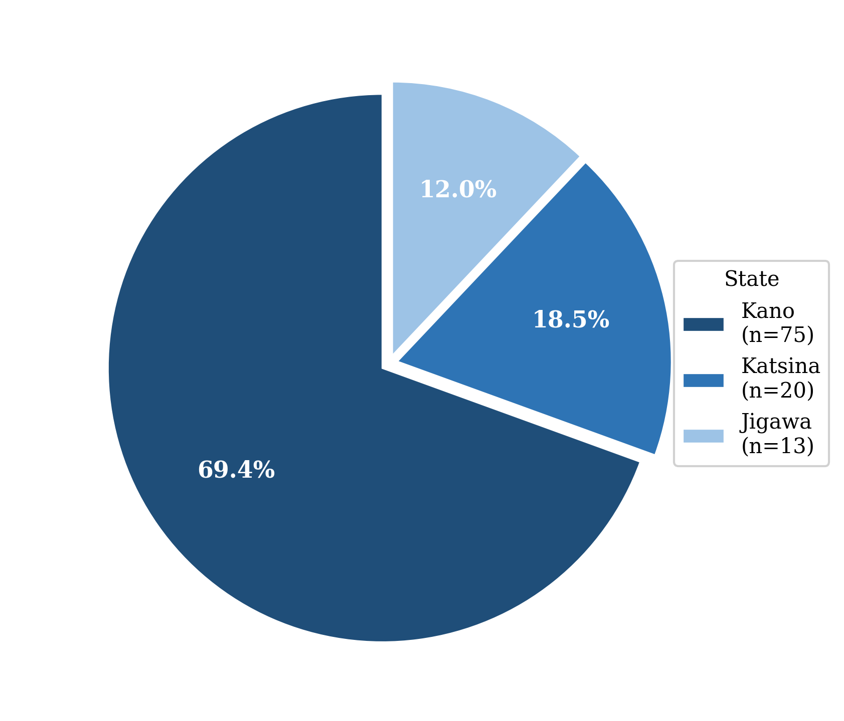
Figure 1. Distribution of respondents by state of work (n = 108).

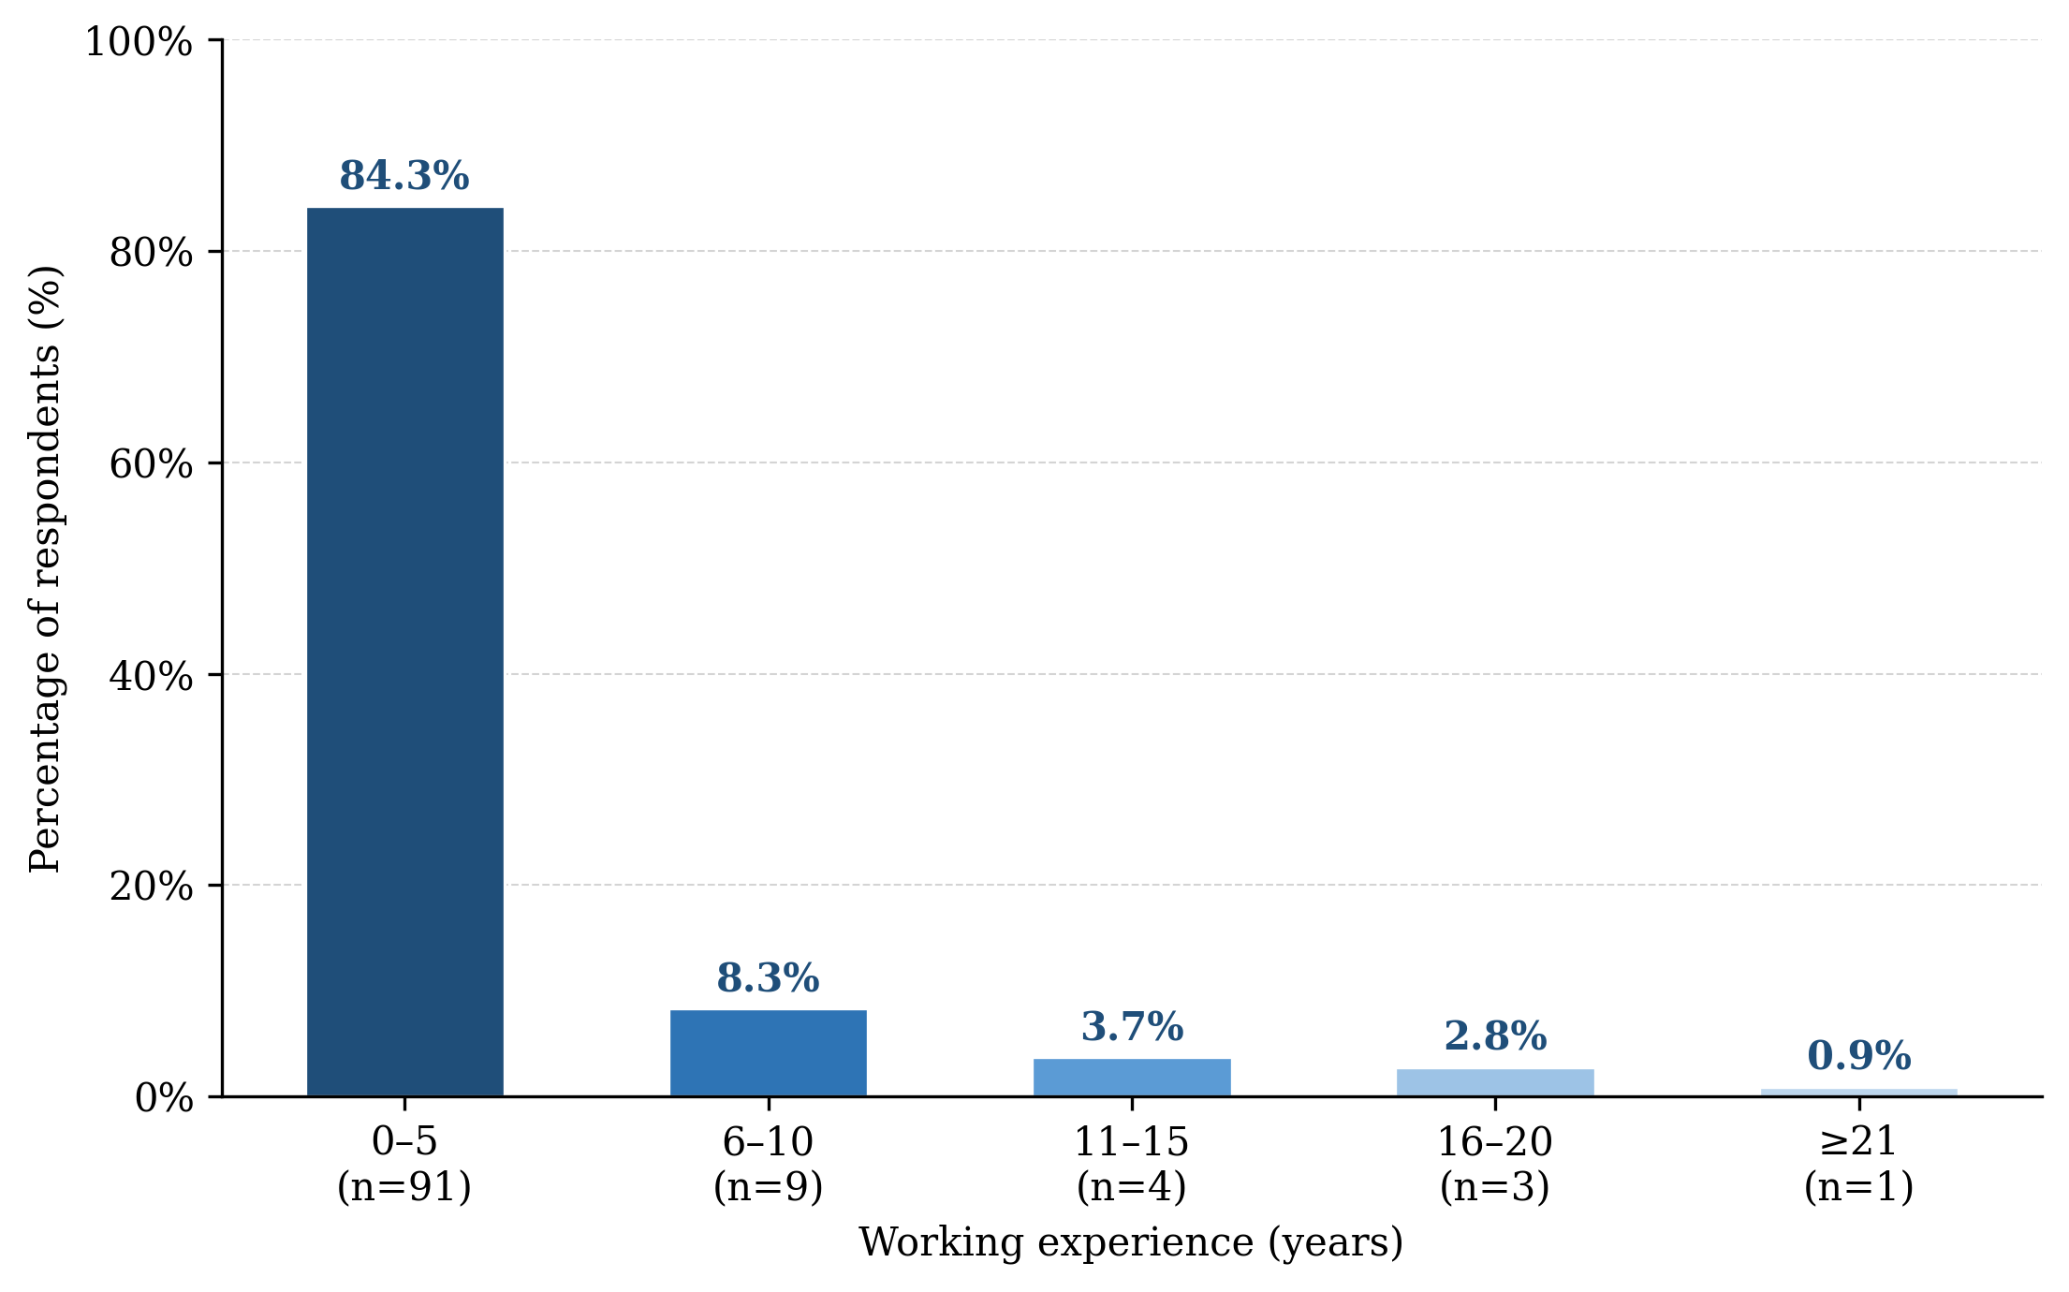
Figure 2. Distribution of respondents by working experience.

Knowledge of Radiotherapy and PGD Radiotherapy
Table 2 presents the percentage responses to knowledge items (Q6–Q13). All 108 respondents (100.0%) correctly identified cancer as the condition treated by radiation therapy (Q6), and all correctly identified brachytherapy as the internal delivery of radioactive substances (Q8). One hundred and six respondents (98.1%) knew that radiation therapy can be delivered both externally and internally (Q7). Eighty-five respondents (81.0%) correctly identified fractionation as the process of dividing the radiation dose into multiple fractions (Q9); notably, a minority of respondents (17.1%) selected the incorrect option (fragmentation), indicating a specific gap in radiotherapy terminology. Regarding the RRBN PGD Radiotherapy program, 106 respondents (98.1%) were aware of its existence (Q10). Eighty-four respondents (77.8%) correctly identified the one-year duration of the program (Q11), while only 80 (74.1%) correctly identified Lagos as the location of the program (Q12). Regarding the registration fee for all three modules, responses were evenly split between the two amounts, with 6.7% indicating no knowledge (Q13).
Table 2
Percentage Responses to Items on Knowledge of Radiotherapy and PGD Radiotherapy (n = 108)
Question | A (%) | B (%) | C (%)
Q6: Radiation therapy is used to treat | 100.0 | 0.0 | 0.0
Q7: Mode of delivery of radiation therapy | 98.1 | 0.9 | 0.9
Q8: Internal delivery of radioactive substance is called | 100.0 | 0.0 | 0.0
Q9: Process of dividing dose into multiple fractions | 17.1 | 81.0 | 1.9
Q10: RRBN offers a PGD in Radiotherapy | 98.1 | 0.9 | 0.9
Q11: Duration of the PGD Radiotherapy program | 77.8 | 21.4 | 0.8
Q12: Which institute branch is running the program | 21.1 | 74.1 | 4.8
Q13: Total registration fee for the three modules | 46.7 | 46.7 | 6.7

Note: correct answers are: Q6: A = cancer; Q7: A = externally and internally; Q8: A = brachytherapy; Q9: B = fractionation (A = fragmentation); Q10: A = yes; Q11: A = one year; Q12: B = Lagos; Q13: A = ₦450,000.
Attitude towards PGD Radiotherapy
Table 3 presents responses to the six attitude items (Q14–Q19). One hundred and six respondents (98.1%) considered postgraduate education a means of increasing the competency and accuracy of radiographers in the radiotherapy unit (Q14). Ninety respondents (83.3%) believed postgraduate education would positively influence their promotion at work (Q15). Eighty-four respondents (77.8%) expressed interest in pursuing postgraduate education in radiotherapy (Q16). Only 51 respondents (47.2%) were aware of any government or institutional sponsorship for PGD Radiotherapy (Q17), indicating a major gap in awareness of available funding. Ninety-one respondents (84.3%) indicated they would enroll in the program if it were held in Northwestern Nigeria (Q18), whereas only 26 (24.1%) were willing to travel to Southern Nigeria for the program without sponsorship (Q19).
Table 3
Percentage Responses to Items on Attitude towards PGD Radiotherapy (n = 108)
Question | Yes (%) | No (%)
Q14: PG education increases competency and accuracy of radiographers in the radiotherapy unit | 98.1 | 1.9
Q15: Obtaining PG education would influence promotion at the workplace | 83.3 | 16.7
Q16: Interest in pursuing PG education in radiotherapy | 77.8 | 22.2
Q17: Awareness of government or institutional sponsorship for PGD Radiotherapy | 47.2 | 52.8
Q18: Would enroll in PGD Radiotherapy if program held in Northwestern Nigeria | 84.3 | 15.7
Q19: Would travel to Southern Nigeria for PGD Radiotherapy without sponsorship | 24.1 | 75.9

Note: PG = postgraduate; RRBN = Radiographers Registration Board of Nigeria.

DISCUSSION
This study assessed the knowledge of and attitudes towards postgraduate radiotherapy education among diagnostic radiographers in Kano, Katsina and Jigawa States of Nigeria, regions where newly established radiotherapy centers face acute manpower shortages.⁴
The results showed that respondents had sound foundational knowledge of radiotherapy, with all correctly identifying its application in cancer treatment and the nature of brachytherapy. This is consistent with basic radiotherapy concepts forming part of the undergraduate radiography curriculum. The finding is consistent with Dlama et al.,¹⁶ who reported good knowledge of evidence-based practice among radiographers in North East Nigeria, suggesting that the foundational science is well embedded in training across Nigerian regions. However, the lower accuracy on Q9 (fractionation; 81.0%) and the limited knowledge of the program fee (Q13; 46.7%) indicate specific gaps that targeted educational outreach could address.
Awareness of the RRBN program was high (98.1%), exceeding the 93% reported by Eze et al.¹⁰ for radiographers in Edo and Lagos States and the 86.4% found by Ohemeng et al.,¹⁴ in Ghana. This suggests that information about the program has reached the Northwest region through professional association activities, including RRBN national conferences, which have been identified as important channels for promoting continuing professional development (CPD) and postgraduate education awareness.¹¹ However, logistical details, particularly program location and cost, were less well known, with only 74.1% correctly identifying the Lagos site and nearly half uncertain about the registration fee. This gap in operational knowledge may itself constitute a barrier to enrolment.
Uncertainty about program registration fees also deserves attention. Responses to Q13 were almost evenly split between the two stated amounts, with 6.7% of respondents indicating no knowledge of the cost whatsoever. While fee uncertainty does not directly prevent enrolment, it points to a gap in operational knowledge that may add to hesitancy, particularly among early-career radiographers. This finding is consistent with Zafar et al.,¹³ who similarly documented that knowledge gaps among health care providers were most pronounced for specific procedural and regulatory details, precisely the category to which program fees and logistics belong. The RRBN and affiliated professional associations should ensure that accurate, current program fee information is disseminated through official channels, including the RRBN website, national conferences and state radiography association platforms.
The overall attitude of respondents towards postgraduate education in radiotherapy was strongly positive, with 98.1% recognizing its role in enhancing clinical competency. This finding mirrors the very high attitude scores reported by Ugwu et al.¹¹ in South Eastern Nigeria and the 80% willingness to enroll found by Eze et al.¹⁰ in Edo and Lagos States. The 77.8% of respondents in the present study who expressed interest in pursuing PGD Radiotherapy is also comparable to the intrinsic motivational factors described by Mubuuke and Pope,⁹ who found that radiographers’ inner desires for professional development, new challenges and career progression were key drivers of postgraduate education decisions. The recognition by 83.3% of respondents that postgraduate education would influence their workplace promotion is consistent with Mubuuke and Pope’s⁹ observation that improved remuneration and career advancement are important extrinsic motivators, and with Byenfeldt et al.’s⁶ finding that elevated professional status was rated highly (mean score 9.2 out of 10) among Swedish radiographers’ reasons for seeking advanced-level knowledge. Yordanova’s¹² finding that Bulgarian radiographers demonstrated similarly high intrinsic motivation for competence expansion, with structural access barriers, rather than lack of interest, being the primary deterrent to advancement, supports the pattern observed in this study.
Despite positive attitudes, two major barriers emerged: distance and lack of sponsorship. Only 24.1% of respondents were willing to travel to Southern Nigeria for the program without financial support, compared with 84.3% who would enroll if the program were held in Northwestern Nigeria. All respondents identified lack of government sponsorship as a major obstacle. This pattern closely replicates the findings of Eze et al.,¹⁰ where 91% of respondents cited university system instability and lack of government sponsorship as hindrances, and of Moonsamy,¹⁷ who identified lack of funding and non-recognition of postgraduate qualifications in human resource frameworks as primary barriers among radiographers in KwaZulu-Natal. Mubuuke and Pope⁹ similarly found that all nine participants in their qualitative study reported funding as a major challenge, with several requiring bank loans and others abandoning postgraduate plans after repeated scholarship failures. Ugwu et al.¹¹ described organizational barriers, limited program availability and stringent enrolment requirements, as the dominant bottleneck in Nigeria, a finding that aligns with the distance and access constraints identified in the present study.
The concentration of the RRBN PGD Radiotherapy program at a single southern institute creates a structural geographical barrier that disproportionately affects radiographers in the North. This is particularly consequential given that North West Nigeria currently has new radiotherapy centers in operation that urgently require qualified therapy radiographers.⁴ Decentralization of the program to a northern institute, combined with government sponsorship or study leave provisions, would likely produce a substantial increase in enrolment, as evidenced by the 84.3% conditional willingness found in this study.
These findings carry practical policy implications. The RRBN should establish an accredited PGD Radiotherapy center in Northern Nigeria to eliminate the distance barrier. Federal and state governments should institute sponsorship schemes and study leave entitlements for radiographers seeking postgraduate radiotherapy qualifications, recognizing this investment as a strategic component of cancer service expansion. Professional associations should use national fora to disseminate accurate information on program costs and logistics to address the gaps in operational knowledge identified in this study. These recommendations align with what the broader literature suggests: Mubuuke and Pope⁹ advocate for government educational loans and local program establishment; Byenfeldt et al.⁶ call for legally regulated modality-based specialization positions that would create institutional demand for advanced-level courses; and Ugwu et al.¹¹ recommend increased program capacity, additional academic faculty and reduced program duration and cost.
This study was limited by a relatively modest sample size (n = 108), confined to three states, which may restrict the generalizability of findings to other Northern Nigerian regions. The cross-sectional design precludes causal inference. Non-response bias is possible given the 77.1% response rate, and the binary Yes/No format of attitude items, while appropriate for this exploratory level of analysis, did not capture the depth of respondents’ views. Future studies should employ larger, multi-state samples and consider qualitative methods to explore the specific logistical and financial barriers in greater detail.
CONCLUSION
Radiographers in Kano, Katsina and Jigawa States of Nigeria demonstrate basic knowledge of radiotherapy and a consistently positive attitude towards postgraduate education in radiotherapy. The primary deterrents to enrolment are not lack of knowledge or motivation, but rather structural barriers of geographical distance and inadequate funding. It is recommended that the RRBN accredit and establish the PGD Radiotherapy program in Northern Nigeria, and that relevant government agencies and hospital administrations provide sponsorship and study leave to enable qualified radiographers in the study area to obtain this specialization. Addressing these barriers is urgent given the expanding radiotherapy infrastructure in North West Nigeria and the critical shortage of qualified therapy radiographers.
ACKNOWLEDGEMENTS
The authors wish to extend special thanks to all lecturers at the Institute of the RRBN, to the Radiotherapists and Medical Physicists of the NSIA-LUTH Cancer Treatment Centre, Lagos, and to all study participants for their cooperation and time.
CONFLICT OF INTEREST: The authors declare no conflict of interest.
FUNDING: This research received no external funding.

REFERENCES
1. Sung H, Ferlay J, Siegel RL, Laversanne M, Soerjomataram I, Jemal A, et al. Global cancer statistics 2020: GLOBOCAN estimates of incidence and mortality worldwide for 36 cancers in 185 countries. CA Cancer J Clin. 2021;71(3):209–49.
2. Jemal A, Bray F, Forman D, O'Brien M, Ferlay J, Center M, et al. Cancer burden in Africa and opportunities for prevention. Cancer. 2012;118(18):4372–84.
3. Nwankwo KC, Dawotola DA, Sharma V. Radiotherapy in Nigeria: Current status and future challenges. West Afr J Radiol. 2013;20(2):84–8.
4. Tumba N, Adewuyi SA, Eguzo K, Adenipekun A, Oyesegun R. Radiotherapy waiting time in Northern Nigeria: Experience from a resource-limited setting. Ecancermedicalscience. 2020; 14:1097.
5. Mohabir I. Factors influencing radiographers’ decision making in relation to postgraduate education [Unpublished MSc dissertation]. Durban: Durban University of Technology; 2019.
6. Byenfeldt M, Lundvall LL, Olofsson PT, Kihlberg J. A survey of Swedish radiographers’ needs for knowledge at advanced level. Radiography. 2025; 31:102913.
7. Gianfaldoni S, Gianfaldoni R, Wollina U, Lotti J, Tchernev G, Lotti T. An overview on radiotherapy: From its history to its current applications in dermatology. Open Access Maced J Med Sci. 2017;5(4):521–5.
8. Prasanna A, Ahmed MM, Mohiuddin M, Coleman CN. Exploiting sensitisation windows of opportunity in hyper and hypo-fractionated radiation therapy. J Thorac Dis. 2014;6(1):4.
9. Mubuuke AG, Pope E. Factors that influence radiographers’ decisions to pursue postgraduate education: An exploratory qualitative study. J Med Imaging Radiat Sci. 2015;46(2):223–30.
10. Eze CU, Abonyi LC, Njoku J, Okorie U. A study of the attitudes of radiographers in Edo and Lagos states of Nigeria to postgraduate education. S Afr Radiographer. 2012;50(2):23–6.
11. Ugwu AC, Erondu OF, Onwuazombe CT. Attitudes and barriers to postgraduate education among radiographers in South Eastern Nigeria. Int J Trop Dis Health. 2011;2(2):112–22.
12. Yordanova MZ. Researching the possibilities and attitudes towards expanding the professional competences of radiographers in North-Eastern Bulgaria. J Adv Res Med Health Sci. 2018;4(9):75–9.
13. Zafar M, Farhan A, Shaikh T, Rafiq R, Usman S, Abrar H, et al. Knowledge, attitude and practices regarding radiological modalities among health care providers, Karachi, Pakistan. Int J Health Syst Disaster Manag. 2016;4(4):132.
14. Ohemeng E, Atinga BE, Barima T, Antwi LN. Assessment of attitudes and barriers of Ghanaian radiographers towards postgraduate radiography education. Br J Healthc Med Res. 2022;9(3):181–97.
15. Johnson B, Christensen L. Educational research: Quantitative and qualitative approaches. Boston: Allyn and Bacon; 2000.
16. Dlama ZJ, Laushugno SS, Mathew A, Musa G, Richard I, Sani MU. Knowledge and perceived barriers in the application of evidence-based medical radiography in North East Nigeria. UNILAG J Med Sci Technol. 2019;4(2):111–9.
17. Moonsamy A. Postgraduate education: Personal, organisational and higher educational barriers experienced by radiographers in KwaZulu-Natal [Unpublished master’s thesis]. Durban: Durban University of Technology; 2020.

